Bond futures

# CME Group Website

* Overview of Products <https://www.cmegroup.com/trading/interest-rates/us-treasury.html>
  + Look at different available contracts. Look at how the maturities match with the futures Introduction of new futures contract
  + Reintroduced 20-year Treasury Bonds in early 2020. CME introduced 20-year Treasury Bond futures
  + 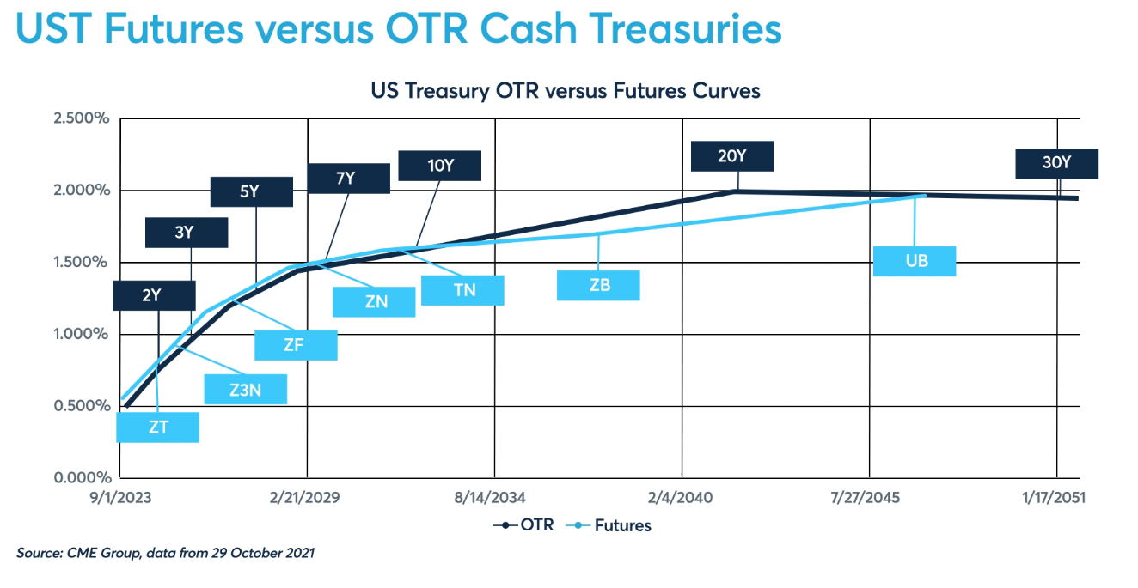
  + <https://www.cmegroup.com/markets/interest-rates/us-treasury/20-year-us-treasury-bond.html>
  + How to Read this chart. Get there from <https://www.cmegroup.com/trading/interest-rates/us-treasury.html>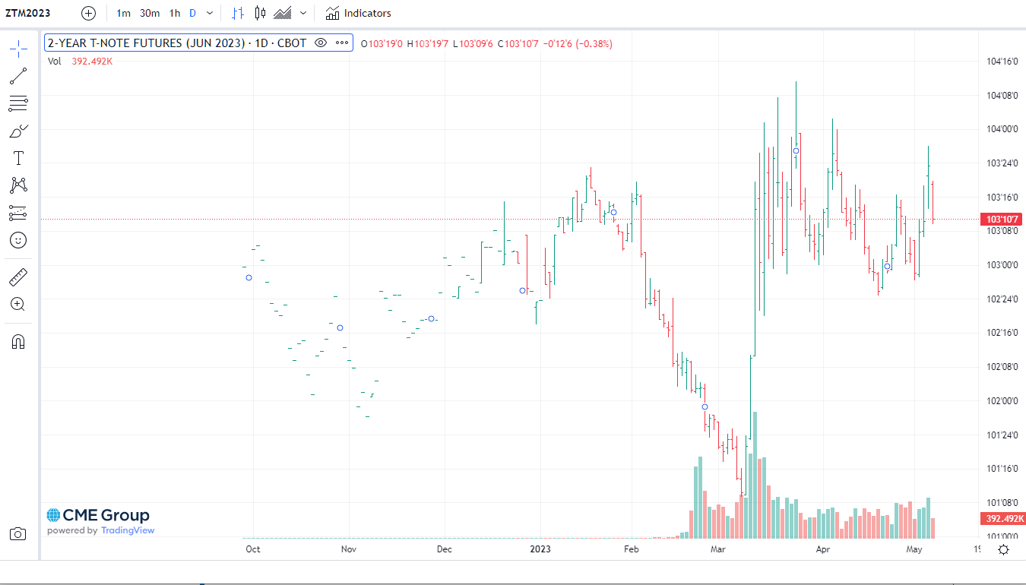
* Check out volumes and open interest. What is open interest? 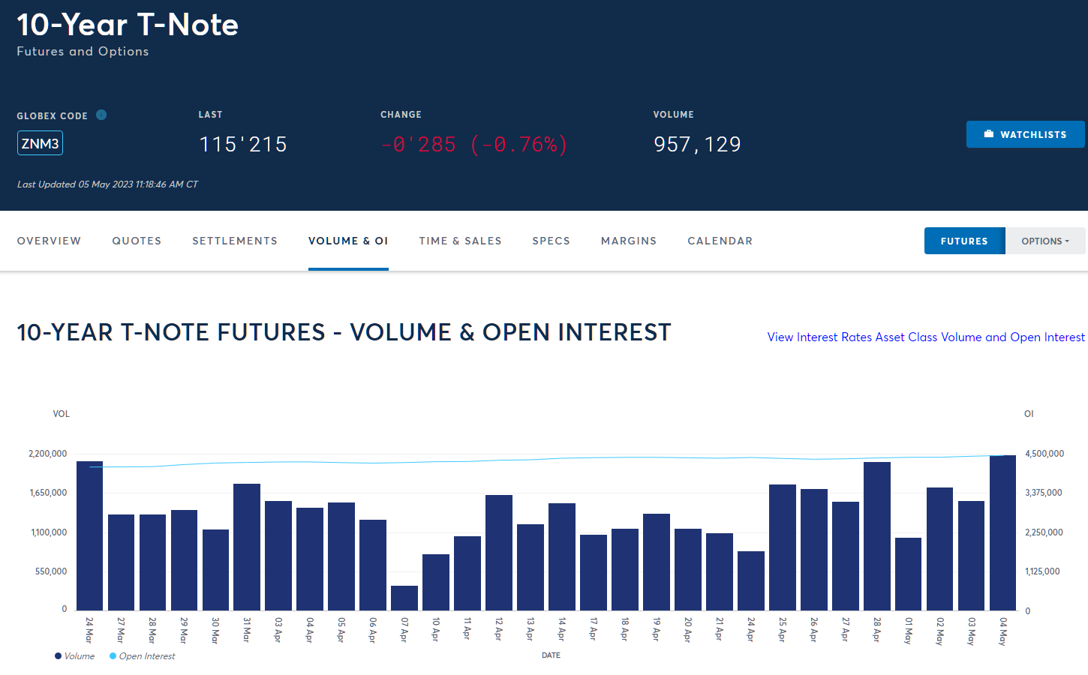
  + <https://www.cmegroup.com/markets/interest-rates/us-treasury/10-year-us-treasury-note.volume.html>

# Jessica Carpenter Notes

* Why is it costless to enter or exit the contract if the listed price is G(t)?
* How is the price G(t) determined?
* Why is it that the price paid at delivery is G(T), but the futures price today is G(t)? I thought the point of a futures contract was to pin down the time T price of delivery in advance at time t? If I don’t know what G(T) is today, how am I guaranteed this certainty today at time t?
  + The certainty is achieved via the daily settlement. If you buy at G(t) and the price moves up at G(t+1), then you receive G(t+1) – G(t).
* <https://pages.stern.nyu.edu/~jcarpen0/courses/b403333/23bondfutures.pdf> 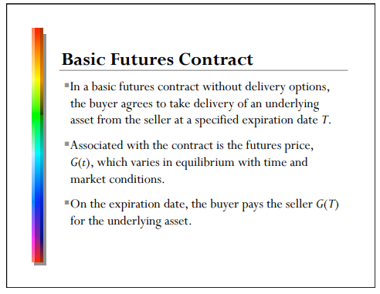
* 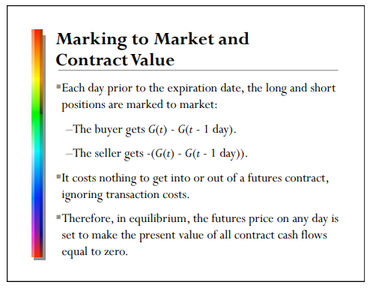
* Which tends to be more expensive? A bond forward or a bond futures? 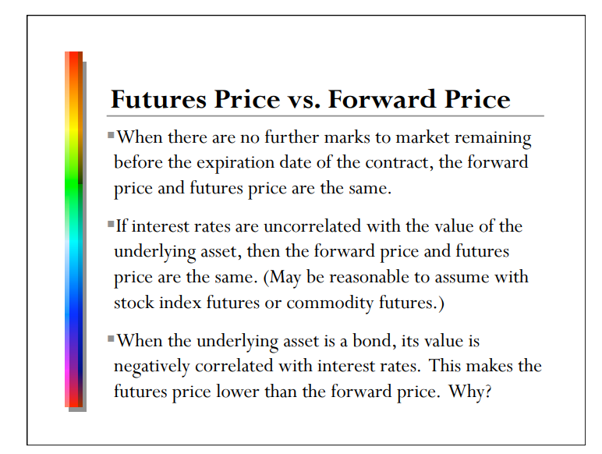
  + The discount rate depends on the interest rate. When the interest rate is higher, that means higher discounting and the value of the future rate does down. If the underlying collateral is also sensitive to interest rates, then this would also affect the price. When interest rates go up, bond prices go down. So, with forwards, there is a double effect. But because of daily settlement of Futures, there are more cash flows in the present. But there is a convexity? 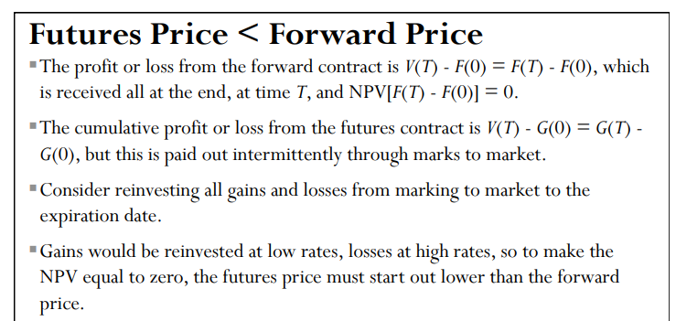
* Let the price of a forward at time 0 be F(0). This entitles the user to buy the underlying for F(T) at time T.
  + Does F(0) necessarily have to be 0?
    - No. In principal it can be anything, but F(T) will depend on F(0). Imagine a situation where F(T)=0 and F(0) >0. Or, imagine a scenario where F(T)>0 and F(0)=), like a future.
  + What must be true about F(T) – F(0)?
    - We must have NPV(F(T) – F(0)) = 0. That means that F(0) = NPV(F(T))
* What is initial margin and variation margin? 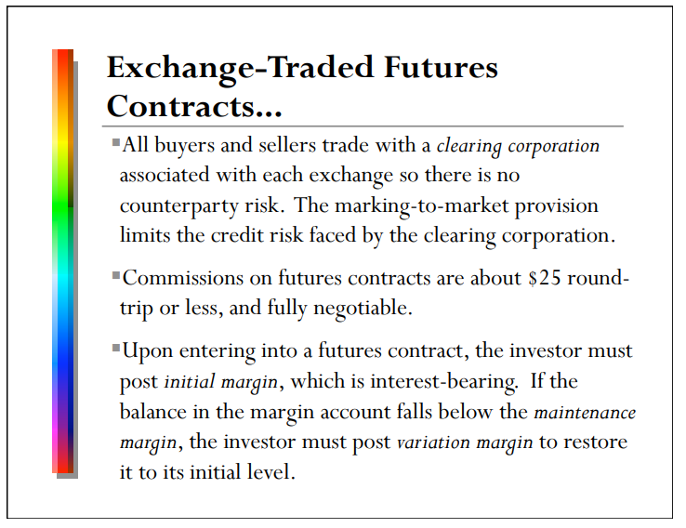

Bloomberg and Cheapest-to-deliver and implied repo rate

* How do contract codes work? <https://www.cmegroup.com/tools-information/vendorSymbol.html>
  + 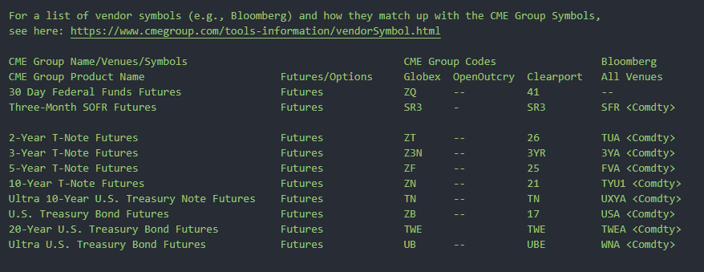
  + Compare Globex codes vs Bloomberg codes. <https://www.cmegroup.com/trading/interest-rates/us-treasury.html>
  + What is Globex?
* 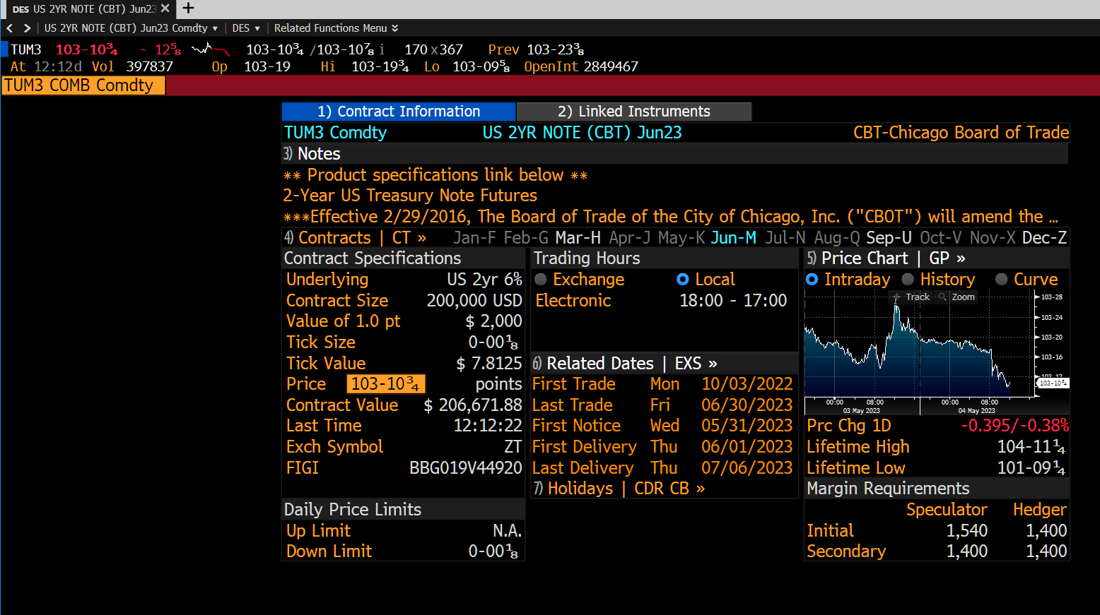
* How to find cheapest to deliver in Bloomberg?
* What is the implied repo rate?
* What about historical cheapest to deliver?